HOW TO USE OUR ONLINE PORTAL (SDL) HERE AT THE BERKELEY CONSTRUCTION OFFICE:
- In your search engine find our website: http://www.berkeleytownship.org/contact_us/town_hall.php .
- Go to the Departments tab and click on the Construction Dept.

- Once there scroll down until you see :

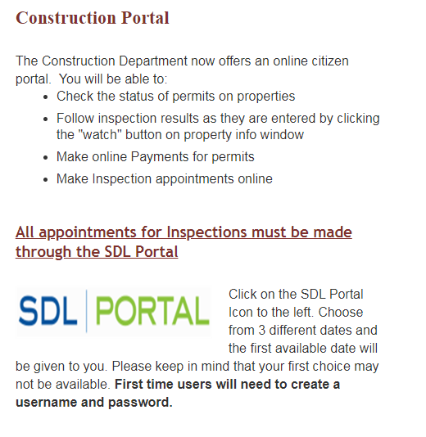
- Click on the icon and it will bring you to our portal page, here you will register with the twp. and create a username and password for future login.
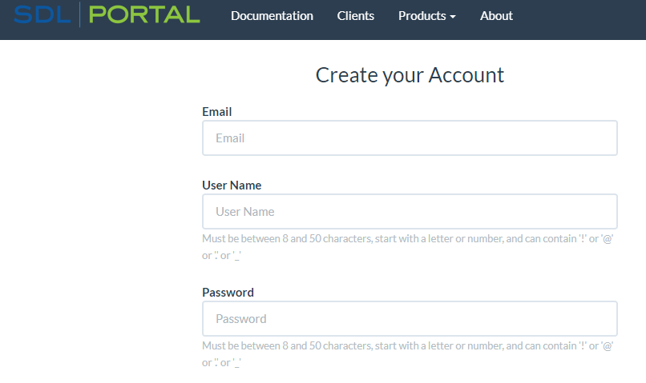
***Please note to use Berkeley when asked about your Twp. To ensure you get the right access to the right town and you will be able to schedule inspections online, search for open permit, permit history and more


